**Assignment No. 2**

***Answer >>>>>***

Step 1 for all jobs >> To create a job click on new item then enter name and select freestyle project and click ok

1. **Job 1 )**

Step 1) integrate Git and Jenkins

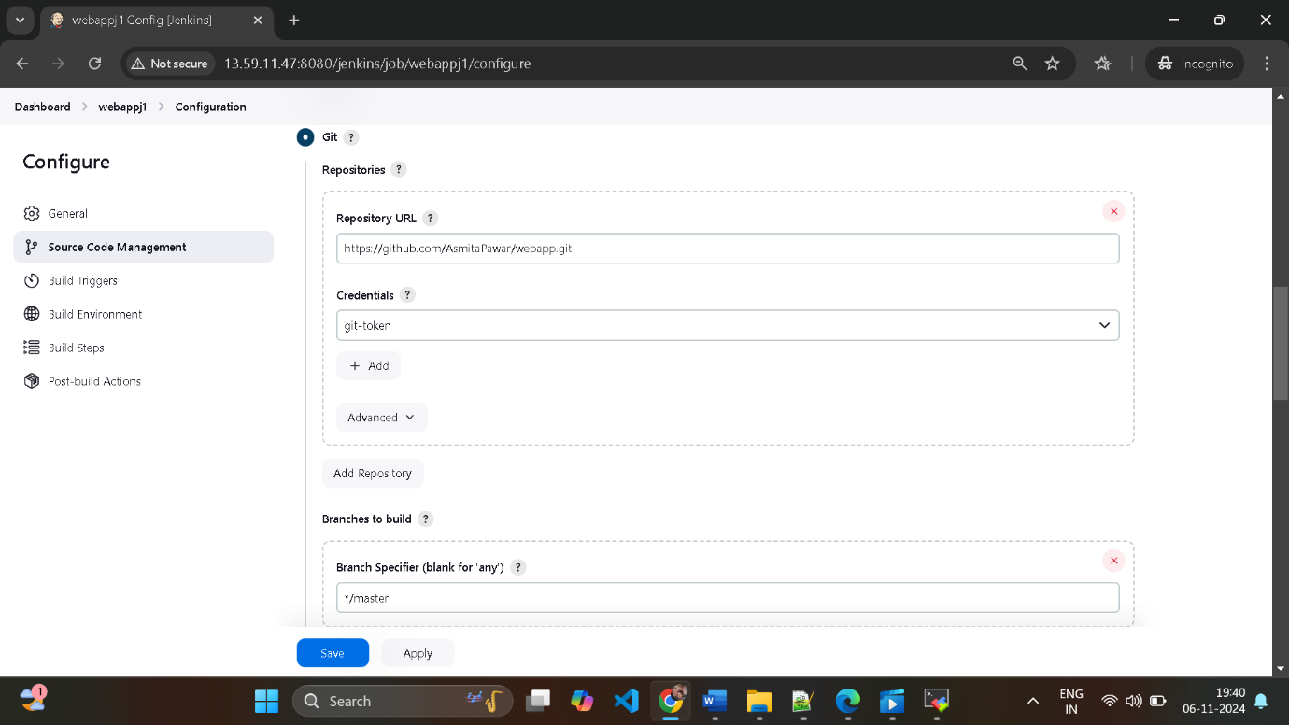

Select specific branch that is master

Step 2) Select the option

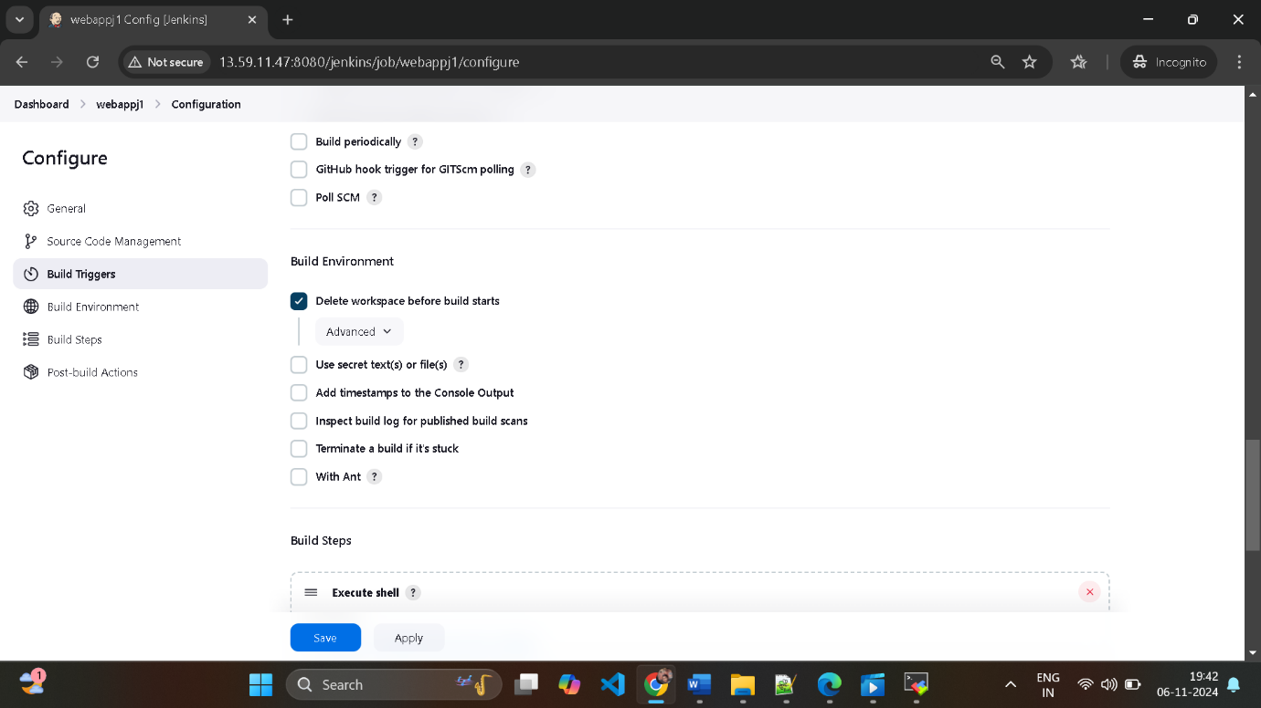

Step 3 ) In build steps select execute shell

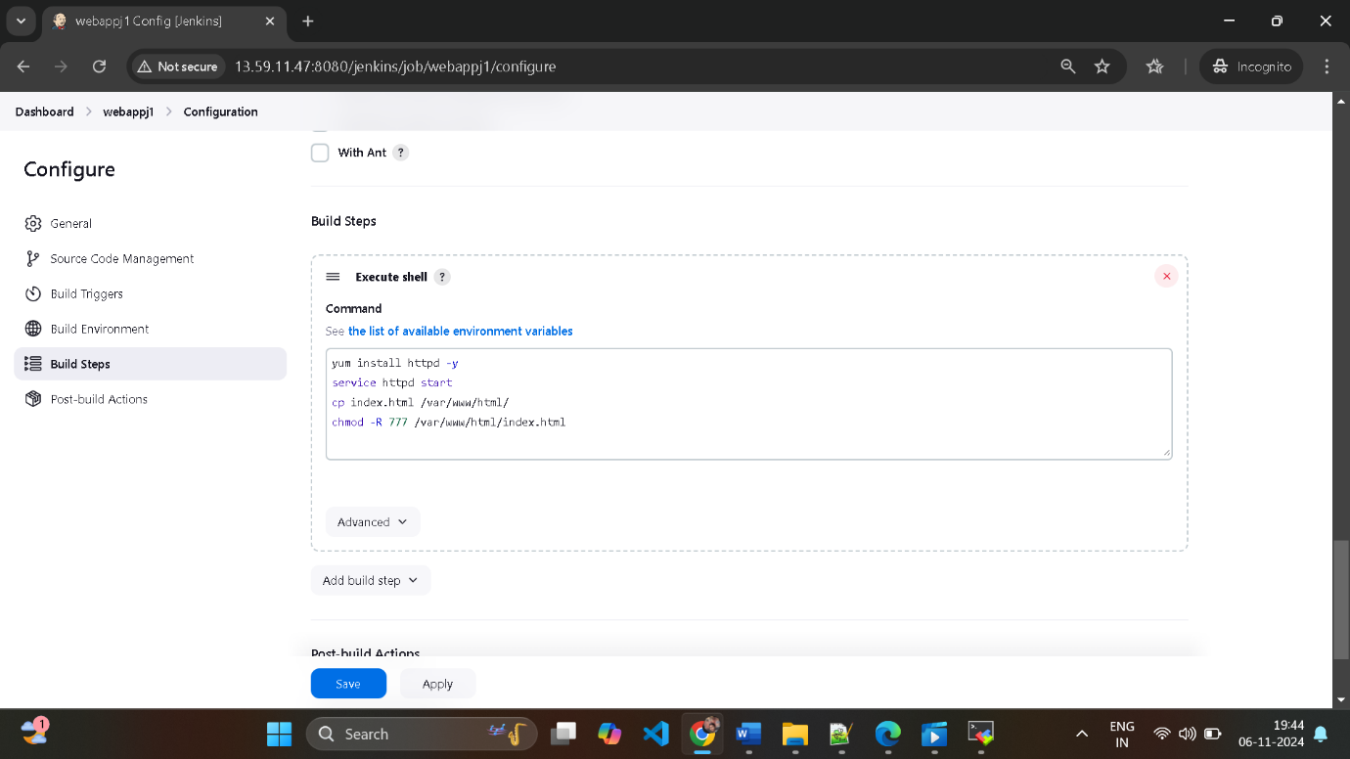

And then apply and save

Step 4) click on build now and check build history and check console output

Started by user [asmita](http://13.59.11.47:8080/jenkins/user/asmita_64)

Running as SYSTEM

Building in workspace /root/.jenkins/workspace/webappj1

[WS-CLEANUP] Deleting project workspace...

[WS-CLEANUP] Deferred wipeout is used...

[WS-CLEANUP] Done

The recommended git tool is: NONE

using credential git-token

Cloning the remote Git repository

Cloning repository <https://github.com/AsmitaPawar/webapp.git>

> git init /root/.jenkins/workspace/webappj1 # timeout=10

Fetching upstream changes from <https://github.com/AsmitaPawar/webapp.git>

> git --version # timeout=10

> git --version # 'git version 2.40.1'

using GIT_ASKPASS to set credentials git-token

> git fetch --tags --force --progress -- <https://github.com/AsmitaPawar/webapp.git> +refs/heads/*:refs/remotes/origin/* # timeout=10

> git config remote.origin.url <https://github.com/AsmitaPawar/webapp.git> # timeout=10

> git config --add remote.origin.fetch +refs/heads/*:refs/remotes/origin/* # timeout=10

Avoid second fetch

> git rev-parse refs/remotes/origin/master^{commit} # timeout=10

Checking out Revision efbf848dd9ca6d40640da66b4779d4f485f2adab (refs/remotes/origin/master)

> git config core.sparsecheckout # timeout=10

> git checkout -f efbf848dd9ca6d40640da66b4779d4f485f2adab # timeout=10

Commit message: "Update index.html"

> git rev-list --no-walk efbf848dd9ca6d40640da66b4779d4f485f2adab # timeout=10

[webappj1] $ /bin/sh -xe /mnt/servers/apache-tomcat-9.0.96/temp/jenkins15663697783572680930.sh

+ yum install httpd -y

Loaded plugins: extras_suggestions, langpacks, priorities, update-motd

Package httpd-2.4.62-1.amzn2.0.2.x86_64 already installed and latest version

Nothing to do

+ service httpd start

Redirecting to /bin/systemctl start httpd.service

+ cp index.html /var/www/html/

+ chmod -R 777 /var/www/html/index.html

Finished: SUCCESS

Step 5)

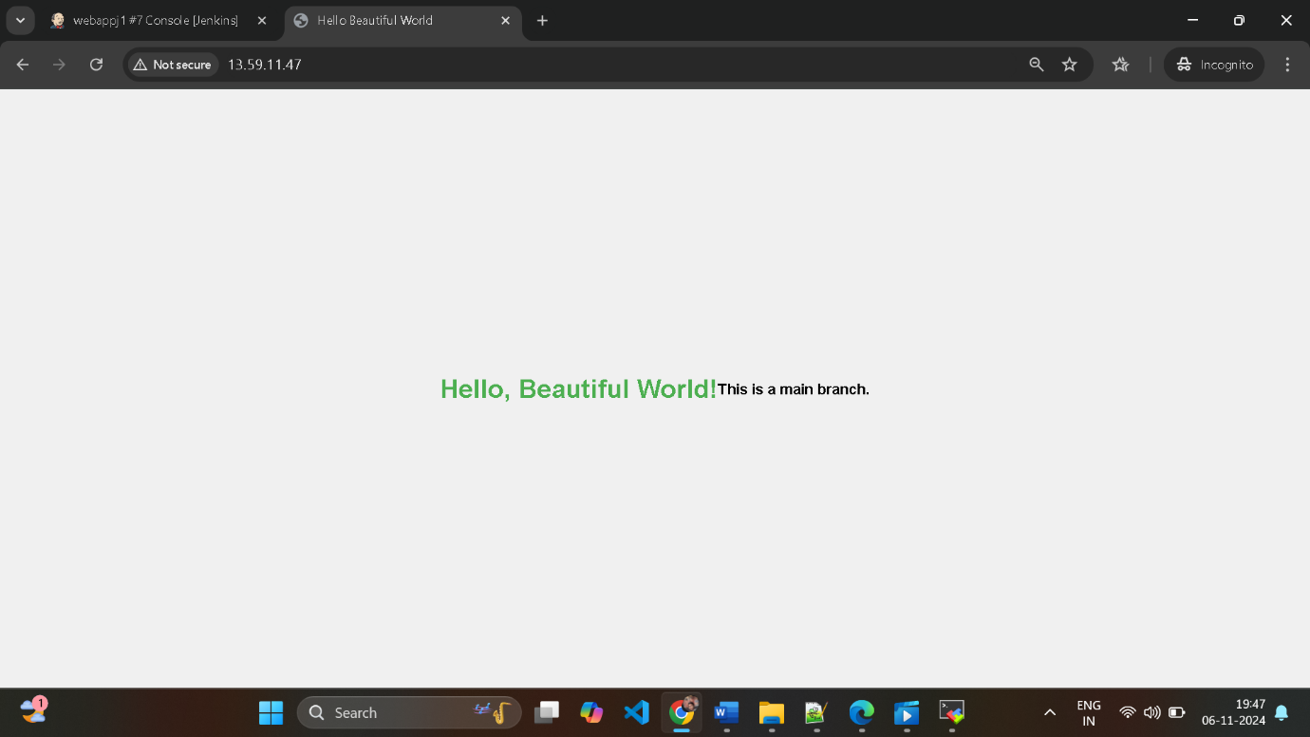

1. **Job 2**

Step 1) integrate Git and Jenkins

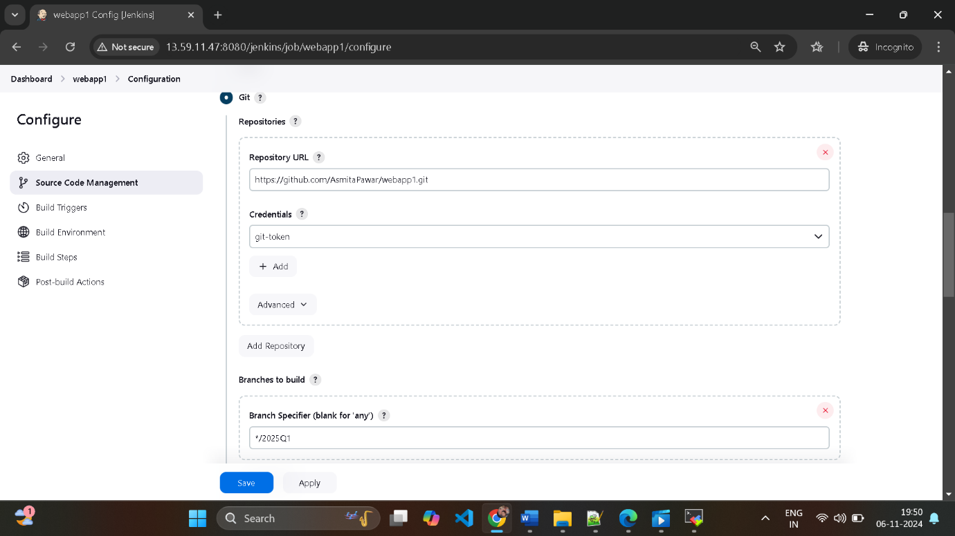

Select specific branch that is 2025Q1

Step 2) Select the option

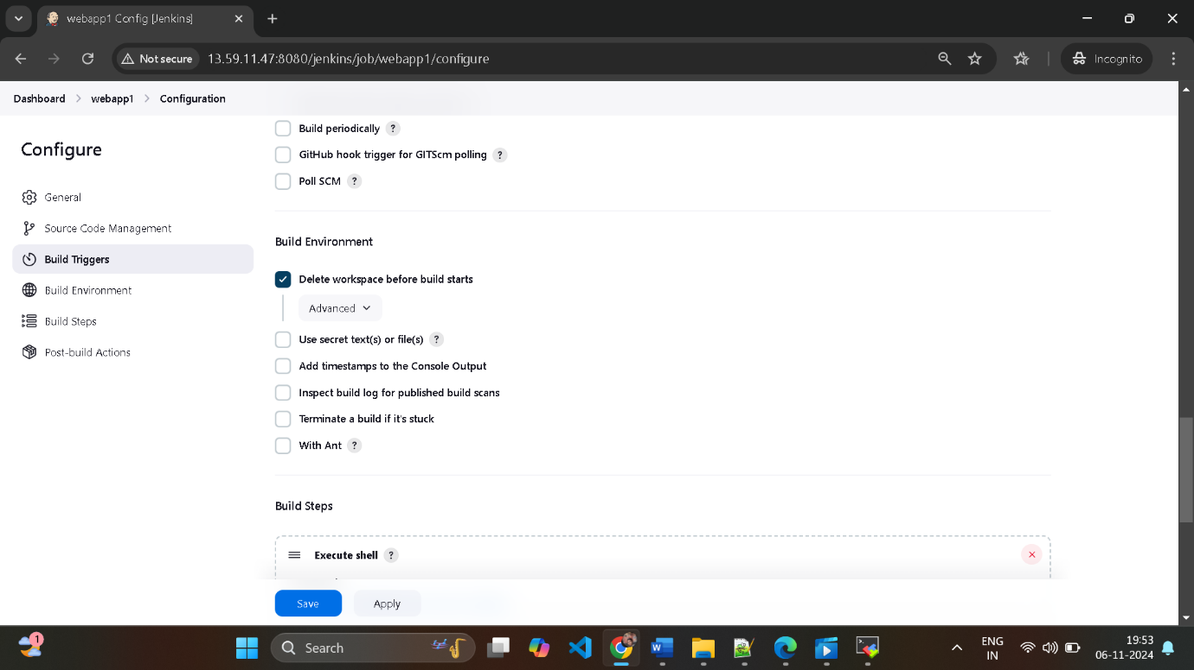

Step 3 ) In build steps select execute shell

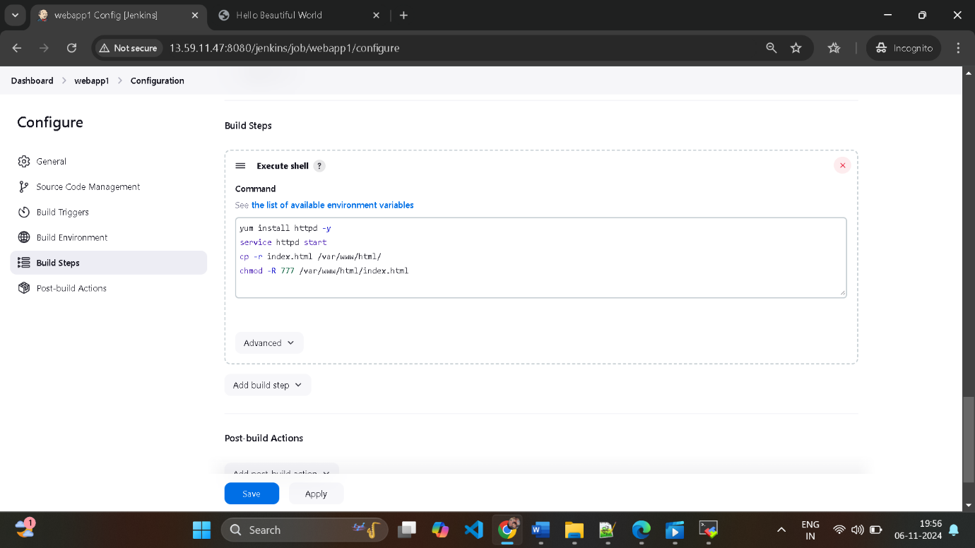

And then apply and save

Step 4) click on build now and check build history and check console output

Started by user [asmita](http://13.59.11.47:8080/jenkins/user/asmita_64)

Running as SYSTEM

Building in workspace /root/.jenkins/workspace/webapp1

[WS-CLEANUP] Deleting project workspace...

[WS-CLEANUP] Deferred wipeout is used...

[WS-CLEANUP] Done

The recommended git tool is: NONE

using credential git-token

Cloning the remote Git repository

Cloning repository <https://github.com/AsmitaPawar/webapp1.git>

> git init /root/.jenkins/workspace/webapp1 # timeout=10

Fetching upstream changes from <https://github.com/AsmitaPawar/webapp1.git>

> git --version # timeout=10

> git --version # 'git version 2.40.1'

using GIT_ASKPASS to set credentials git-token

> git fetch --tags --force --progress -- <https://github.com/AsmitaPawar/webapp1.git> +refs/heads/*:refs/remotes/origin/* # timeout=10

> git config remote.origin.url <https://github.com/AsmitaPawar/webapp1.git> # timeout=10

> git config --add remote.origin.fetch +refs/heads/*:refs/remotes/origin/* # timeout=10

Avoid second fetch

> git rev-parse refs/remotes/origin/2025Q1^{commit} # timeout=10

Checking out Revision d36480d5ae75097460e2a0cc85a9ff22915e1b8b (refs/remotes/origin/2025Q1)

> git config core.sparsecheckout # timeout=10

> git checkout -f d36480d5ae75097460e2a0cc85a9ff22915e1b8b # timeout=10

Commit message: "Update index.html"

> git rev-list --no-walk a56afb2a8d98b8f056091e384f5ff3d2e12c1098 # timeout=10

[webapp1] $ /bin/sh -xe /mnt/servers/apache-tomcat-9.0.96/temp/jenkins3182586345822362841.sh

+ yum install httpd -y

Loaded plugins: extras_suggestions, langpacks, priorities, update-motd

Package httpd-2.4.62-1.amzn2.0.2.x86_64 already installed and latest version

Nothing to do

+ service httpd start

Redirecting to /bin/systemctl start httpd.service

+ cp -r index.html /var/www/html/

+ chmod -R 777 /var/www/html/index.html

Finished: SUCCESS

Step 5)

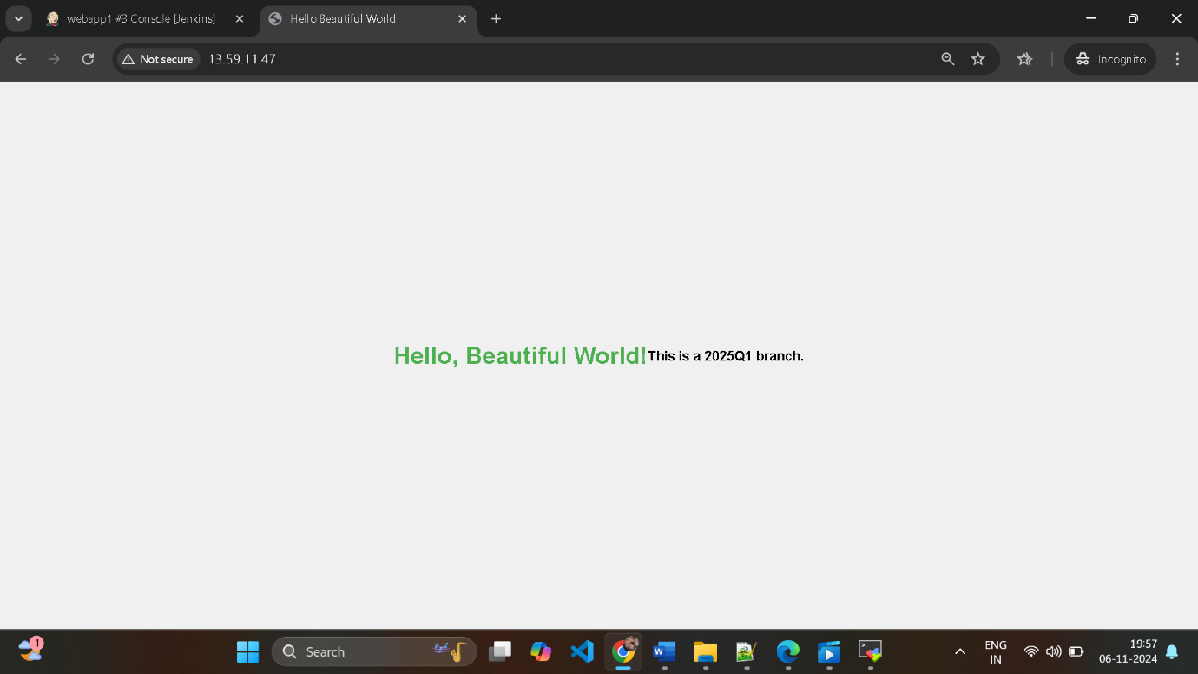

**C ) Job 3**

Step 1) integrate Git and Jenkins

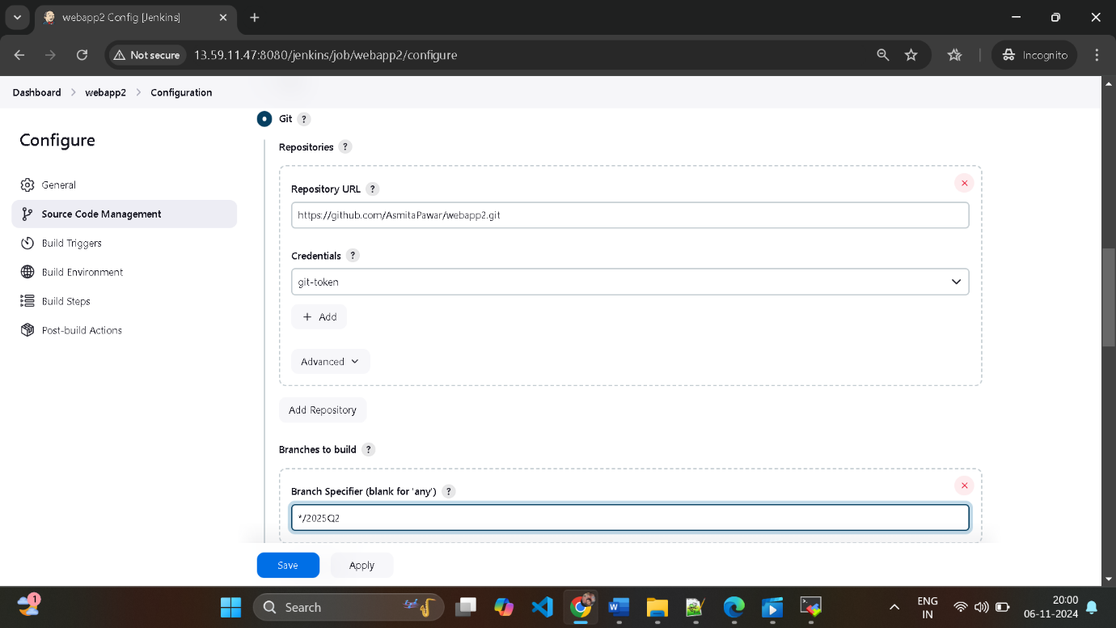

Select specific branch that is 2025Q2

Step 2) Select the option

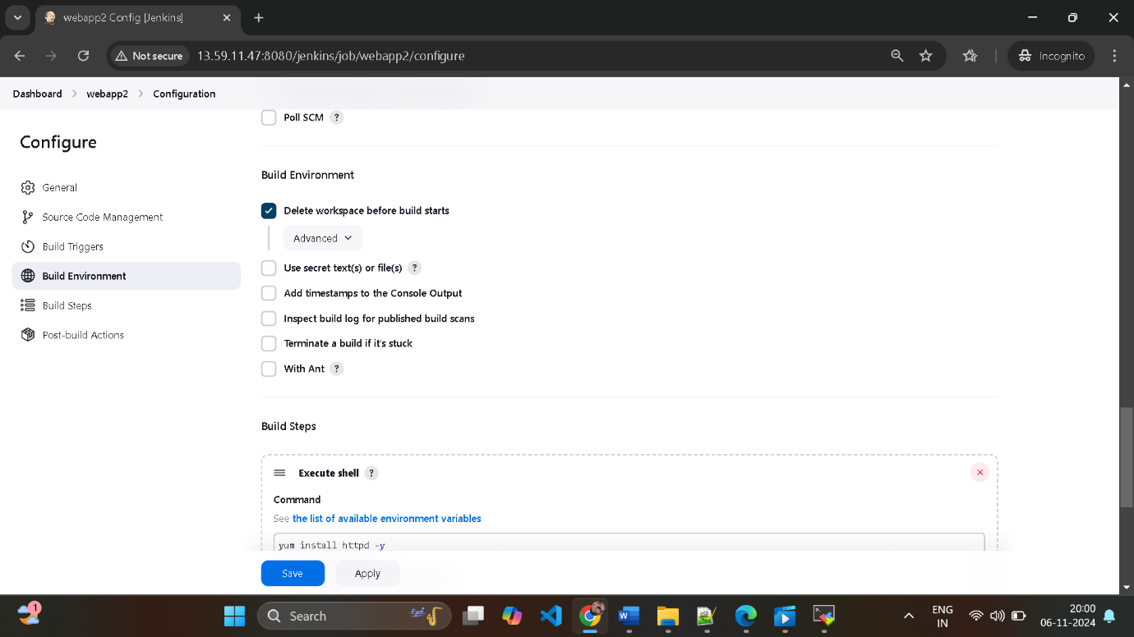

Step 3 ) In build steps select execute shell

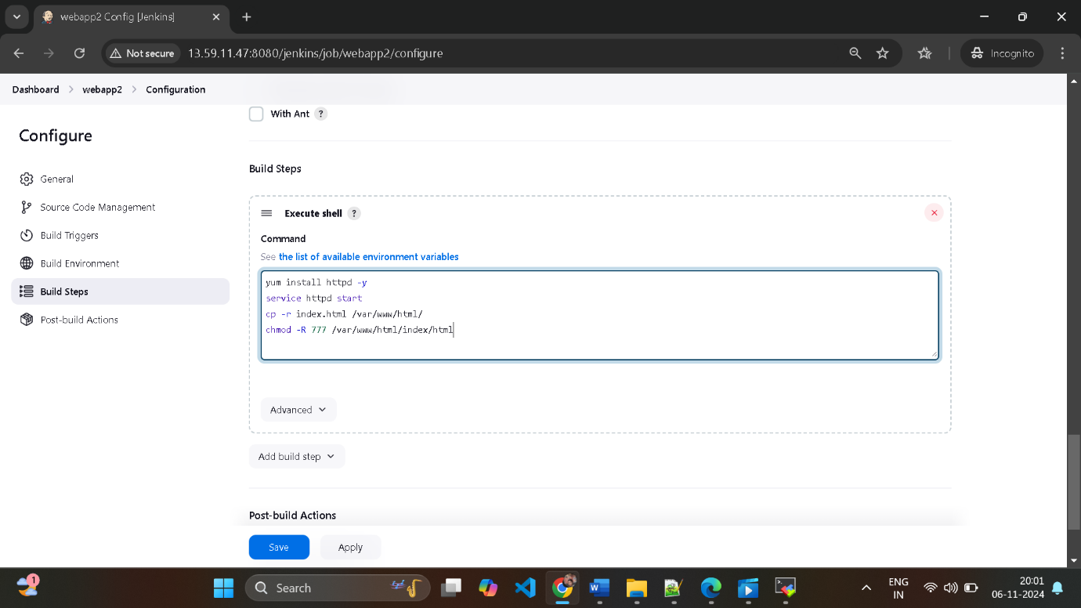

And then apply and save

Step 4) click on build now and check build history and check console output

Started by user [asmita](http://13.59.11.47:8080/jenkins/user/asmita_64)

Running as SYSTEM

Building in workspace /root/.jenkins/workspace/webapp2

[WS-CLEANUP] Deleting project workspace...

[WS-CLEANUP] Deferred wipeout is used...

[WS-CLEANUP] Done

The recommended git tool is: NONE

using credential git-token

Cloning the remote Git repository

Cloning repository <https://github.com/AsmitaPawar/webapp2.git>

> git init /root/.jenkins/workspace/webapp2 # timeout=10

Fetching upstream changes from <https://github.com/AsmitaPawar/webapp2.git>

> git --version # timeout=10

> git --version # 'git version 2.40.1'

using GIT_ASKPASS to set credentials git-token

> git fetch --tags --force --progress -- <https://github.com/AsmitaPawar/webapp2.git> +refs/heads/*:refs/remotes/origin/* # timeout=10

> git config remote.origin.url <https://github.com/AsmitaPawar/webapp2.git> # timeout=10

> git config --add remote.origin.fetch +refs/heads/*:refs/remotes/origin/* # timeout=10

Avoid second fetch

> git rev-parse refs/remotes/origin/2025Q2^{commit} # timeout=10

Checking out Revision 5a51c045f9703a0829724a6e45022574a48eed2e (refs/remotes/origin/2025Q2)

> git config core.sparsecheckout # timeout=10

> git checkout -f 5a51c045f9703a0829724a6e45022574a48eed2e # timeout=10

Commit message: "Update index.html"

First time build. Skipping changelog.

[webapp2] $ /bin/sh -xe /mnt/servers/apache-tomcat-9.0.96/temp/jenkins8259320595225644125.sh

+ yum install httpd -y

Loaded plugins: extras_suggestions, langpacks, priorities, update-motd

Package httpd-2.4.62-1.amzn2.0.2.x86_64 already installed and latest version

Nothing to do

+ service httpd start

Redirecting to /bin/systemctl start httpd.service

+ cp -r index.html /var/www/html/

+ chmod -R 777 /var/www/html/index.html

Finished: SUCCESS

Step 5)

